Batch: C3 Roll No.: 16010123217

Experiment No. 04

Grade: AA / AB / BB / BC / CC / CD /DD

Signature of the Staff In-charge with date

TITLE: CPU Scheduling – Non Preemptive
_____________________________________________________________________

AIM: Implementation of Basic CPU Scheduling Algorithms – Non Preemptive [FCFS , SJF]
______________________________________________________________________
Expected Outcome of Experiment:

CO 2 Illustrate and analyse the Process, threads, process scheduling and thread scheduling _____________________________________________________________________
Books/ Journals/ Websites referred:

- Silberschatz A., Galvin P., Gagne G. “Operating Systems Principles”, Willey Eight edition.
- Achyut S. Godbole , Atul Kahate “Operating Systems” McGraw Hill Third
Edition.
- William Stallings, “Operating System Internal & Design Principles”, Pearson.
- Andrew S. Tanenbaum, “Modern Operating System”, Prentice Hall.
_____________________________________________________________________
Pre Lab/ Prior Concepts:

Most systems handle numerous processes with short CPU bursts interspersed with I/O requests and a few processes with long CPU bursts. To ensure good time-sharing performance, a running process may be preempted to allow another to run. The ready list, or run queue, maintains all processes ready to run and not blocked by I/O or other system requests. Entries in this list point to the process control block, which stores all process information and state.
When an I/O request completes, the process moves from the waiting state to the ready state and is placed on the run queue. The process scheduler, a key component of the operating system, decides whether the current process should continue running or if another should take over. This decision is triggered by four events:
- The current process issues an I/O request or system request, moving it from running to waiting.
- The current process terminates.
- A timer interrupt indicates the process has run for its allotted time, moving it from running to ready.
- An I/O operation completes, moving the process from waiting to ready, potentially preempting the current process.
The scheduling algorithm, or policy, determines the sequence and duration of process execution, a complex task given the limited information about ready processes.

Description of the application to be implemented:
First-Come, First-Served Scheduling:
1- Input the processes along with their burst time (bt).

Two arrays can be taken, One array for Process Id, 2nd array for Corresponding Burst times

2- Find waiting time (wt) for all processes.
3rd Array needed

3- As first process that comes need not to wait so waiting time for process 1 will be 0 i.e. wt[0] = 0.

4- Find waiting time for all other processes i.e. for process i ->
wt[i] = bt[i-1] + wt[i-1] .

Waiting Time = Turn Around Time - Burst Time or Sum of times spent waiting in Ready queue

5- Find turnaround time = waiting_time + burst_time for all processes.

Turnaround Time = Completion Time - Arrival Time

6- Find average waiting time = total_waiting_time / no_of_processes.

7- Similarly, find average turnaround time = total_turn_around_time / no_of_processes.

Shortest job first :
- Sort all the process according to the Burst time, so the shortest one can be executed first, i.e. Sort the process id array and burst time array both according to burst time.
- Once sorted, Similar to FCFS.
- Steps used in FCFS can be used for average waiting time and average turnaround time
Implementation details:
First-Come, First Served Scheduling:
#include <bits/stdc++.h>
using namespace std;

int main(){
cout<<"Enter the number of processes: ";
int n; cin>>n;

vector<pair<pair<int, int>, string>> v1(n);

cout<<"Enter Process ID, Arrival Time, Burst Time for each process:\n";
for (int i = 0; i < n; i++){
string id;
int at, bt;
cin>>id>>at>>bt;
v1[i] = {{at, bt}, id};
}

stable_sort(v1.begin(), v1.end(), [](const auto &a, const auto &b){
return a.first.first < b.first.first;
});

vector<int> ct(n), tat(n), wt(n);
int temp = 0;

for (int i = 0; i< n; i++){
int at = v1[i].first.first;
int bt = v1[i].first.second;

temp = max(temp, at) + bt;
ct[i] = temp;
tat[i] = ct[i] - at;
wt[i] = tat[i] - bt;
}

cout << "\nProcess\tAT\tBT\tCT\tTAT\tWT\n";
for (int i = 0; i< n; i++){
cout<<v1[i].second<<"\t"<<v1[i].first.first<<"\t"<<v1[i].first.second<<"\t"<<ct[i]<<"\t"<<tat[i]<<"\t"<<wt[i]<<endl;
}

return 0;
}

Shortest Job First:
#include <bits/stdc++.h>
using namespace std;

int main(){
cout<<"Enter the number of processes: ";
int n; cin>>n;

vector<pair<pair<int, int>, string>> v1(n);

cout<<"Enter Process ID, Arrival Time, Burst Time for each process:\n";
for (int i = 0; i < n; i++) {
string id;
int at, bt;
cin>>id>>at>>bt;
v1[i] = {{at, bt}, id};
}

stable_sort(v1.begin(), v1.end(), [](const auto &a, const auto &b){
return a.first.second < b.first.second;
});

vector<int> ct(n), tat(n), wt(n);
int temp = 0;

for (int i = 0; i< n; i++){
int at = v1[i].first.first;
int bt = v1[i].first.second;

temp = max(temp, at) + bt;
ct[i] = temp;
tat[i] = ct[i] - at;
wt[i] = tat[i] - bt;
}

cout << "\nProcess\tAT\tBT\tCT\tTAT\tWT\n";
for (int i = 0; i< n; i++){
cout<<v1[i].second<<"\t"<<v1[i].first.first<<"\t"<<v1[i].first.second<<"\t"<<ct[i]<<"\t"<<tat[i]<<"\t"<<wt[i]<<endl;
}

return 0;
}

Output:
FCFS with arrival time 0: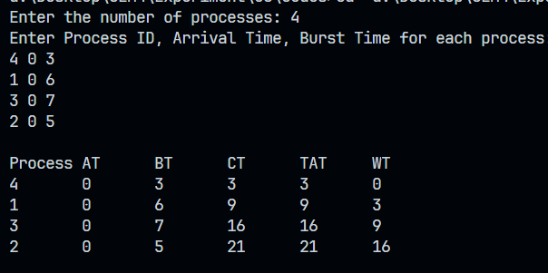
FCFS with varying arrival time:
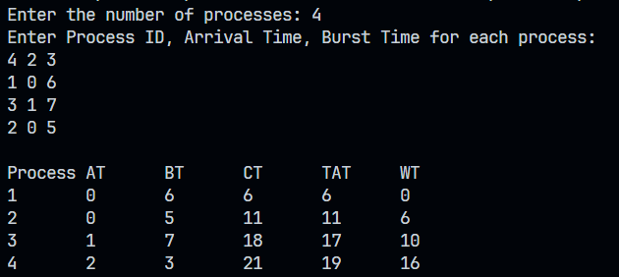
SJF:
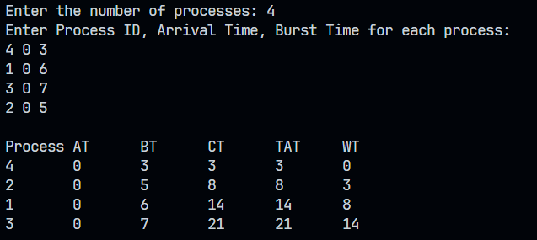
Conclusion :
From this experiment we learnt about scheduling algorithms like fcfs and sjf and understood their pros and cons
Multiple-Choice Questions (MCQs)
- In FCFS scheduling, the process that arrives first:

A) Gets executed first

B) Gets executed last

C) Has the highest priority

D) Has the shortest burst time
Ans. Option A

- Which scheduling algorithm can cause the "Convoy Effect"?

A) FCFS

B) SJF

C) Round Robin

D) Priority Scheduling
Ans. Option A

- SJF scheduling algorithm is also known as:

A) Shortest Remaining Time First

B) Shortest Time Next

C) Longest Job First
Ans. Option A

Post Lab Descriptive Questions

- Compare FCFS and SJF.
Ans. FCFS
1. Scheduling: Jobs are executed in the order they arrive.
2. Advantages: Simple to implement, easy to understand.
3. Disadvantages: Can lead to poor response times, inefficient use of resources.

SJF
1. Scheduling: Jobs are executed in the order of their burst time (shortest first).
2. Advantages: Optimizes average response time, reduces waiting time.
3. Disadvantages: Difficult to implement, requires knowledge of burst times.

- Discuss the impact of SJF scheduling on the average waiting time of processes.
Ans. Shortest Job First (SJF) scheduling has a significant impact on reducing the average waiting time of processes.

Benefits of SJF Scheduling
1. Minimizes Average Waiting Time: SJF scheduling executes the shortest job first, which reduces the waiting time for other processes.
2. Optimizes CPU Utilization: By executing shorter jobs first, SJF ensures that the CPU is utilized efficiently.
3. Improves System Responsiveness: SJF scheduling helps reduce the response time for interactive processes.

Factors Affecting Average Waiting Time
1. Burst Time: The average waiting time is highly dependent on the burst time of processes. SJF scheduling performs well when burst times are short.
2. Process Arrival Pattern: The arrival pattern of processes affects the average waiting time. SJF scheduling is more effective when processes arrive randomly.

Limitations of SJF Scheduling
1. Difficulty in Estimating Burst Time: Accurately estimating the burst time of processes is challenging, which can lead to inefficient scheduling.
2. Starvation: Longer processes may experience starvation, as they are constantly postponed in favor of shorter processes.

- Consider a set of 4 processes with their respective arrival and burst times given in milliseconds.
Process | Arrival Time | Burst Time
P0 | 0 | 20
P1 | 15 | 25
P2 | 30 | 10
P3 | 45 | 15
- Apply the First-Come, First-Served (FCFS) and Shortest Job First (SJF) scheduling algorithms.
- For each scheduling method:
- Draw the Gantt Chart.
- Calculate the Average Turnaround Time.
- Calculate the Average Waiting Time.
- Analyze the results and comment on the performance of FCFS and SJF for the given process set.
Ans.
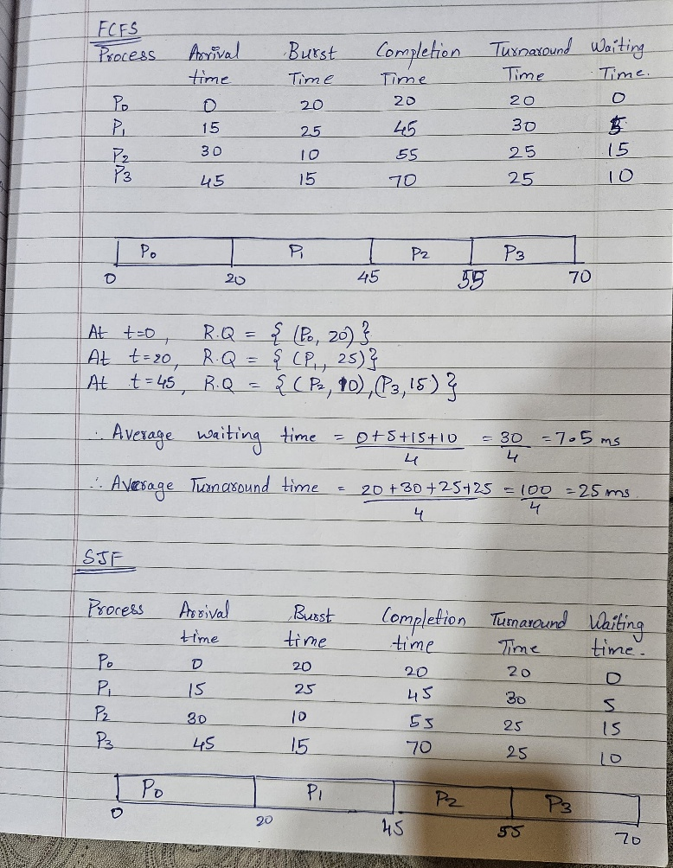
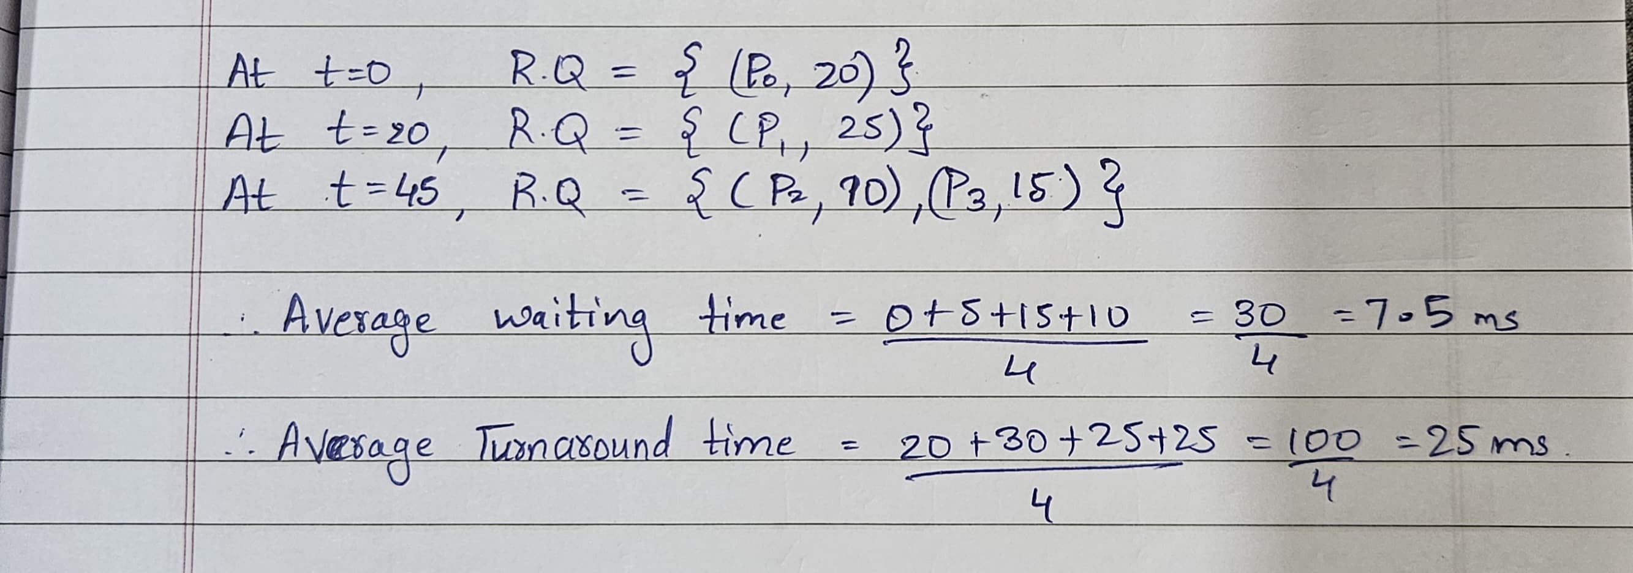
C)
In this specific case, SJF and FCFS result in the same order of execution.
This happens because when each process arrives, there are no multiple choices available at that moment (except at time 45, where P2 is chosen first because it has a shorter burst time).
The shortest job (P2) is already naturally executed first due to its later arrival.

Date: 20-02-25_____ Signature of faculty in-charge

